
- SUN PHARMACEUTICALS INDUSTRIES LTD.

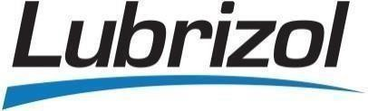
2. LUBRIZOL INDIA PVT LTD.
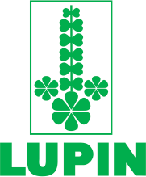
3. LUPIN LTD.

4. ACG CAPSULES PVT LTD.


5. AARTI DRUGS LTD.


6. CAMLIN FINE SCIENCES LTD.


7. LAXMI ORGANICS LTD.


8. JOHNSON & JOHNSON



9. STERLITE TECHNOLOGIES LTD.

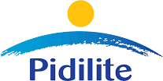
10. PIDILITE INDUSTRIES LTD.


11. HARMAN FINOCHEM LTD.


12. IPCA LABORATORIES LTD.


13. APCOTEX INDUSTRIES LTD.
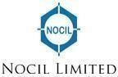

14. NOCIL LTD.



15. AARTI PHARMALABS LTD.



16. SAREX OVERSEAS.

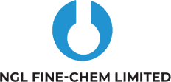

17. NGL FINE-CHEM LIMITED.

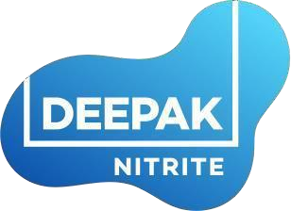

18. DEEPAK NITRITE PVT LTD.



19. RAMDEV CHEMICALS PVT LTD.

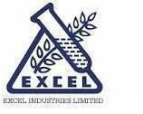
20. EXCEL INDUSTRIES LTD.


21. RECYKAL PVT LTD.


22. SEQUENT SCIENTIFIC LTD.

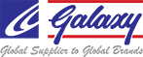
23. GALAXY SURFACTANTS LTD.


24. AQUAPHARM CHEMICALS PVT LTD.



25. AARTI INDUSTRIES LTD



26. Unimax Chemicals Pvt. Ltd.


27. SUN CHEMICALS


28. BIOSTADT INDIA LTD

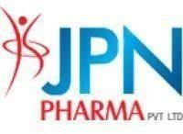
29. JPN PHARMA PVT LTD.

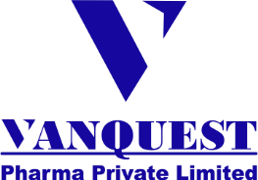

30. VANQUEST PHARMA PVT LTD

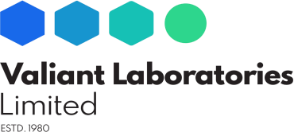
31. VALIANT LABORATORIES LTD


32. WARREN REMEDIES PVT LTD

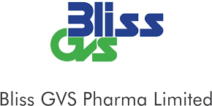
33. BLISS GVS PHARMA LTD

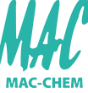
34. MAC-CHEM PRODUCTS PVT LTD


35 AQUAPHARMA CHEMICALS PVT LTD

